### C:\Users\BHAVANA TRADERS\Desktop\kumar\SMART INTERZ.png C:\Users\BHAVANA TRADERS\Desktop\kumar\BRIDGE.pngC:\Users\BHAVANA TRADERS\Desktop\kumar\APSCHE.jpg

### PROJECT TITLE: “CREATION OF AN APPLICATION

### FOR SCHOOL MANAGEMENT”

### C:\Users\BHAVANA TRADERS\Desktop\kumar\PROJRCT.pngC:\Users\BHAVANA TRADERS\Desktop\kumar\management.jpg

### PRESENTED BY, TEAM ID: LTVIP2023TMID11602

### TEAM LEADER: 1. C. pavani

### Introduction

**What Is Salesforce?**  
 Salesforce is your customer success platform, designed to help you sell, service, market, analyze, and connect with your customers.  
  
Salesforce has everything you need to run your business from anywhere. Using standard products and features, you can manage relationships with prospects and customers, collaborate and engage with employees and partners, and store your data securely in the cloud

**Creating Developer Org**

**Creating a developer org in salesforce.**

Go to developer.salesforce.com

Click on sign up.

On the sign up form, enter the following details

a. First name & Last name

b. Email

c. Role - Developer

d. Company - College Name

e. Country - India

f. Postal Code - pin code

g. Username- should be a combination of your name and company

This need not be an actual email id, you can give anything in the format :

username@organization.com

Click on sign up after filling these.

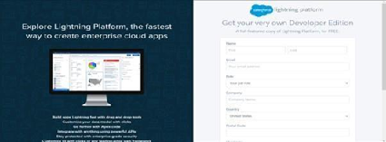

Account Activation

Go to the inbox of the email that you used while signing up. Click on the verify account to activate your account. The email may take 5-10mins, as

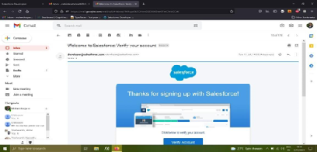

Login To Your Salesforce Account

Go to salesforce.com and click on login.

Enter the username and password that you just created.

After login this is the home page which you will see.

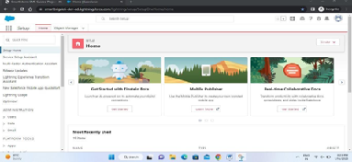

Salesforce Login

htttps://login.salesforce.com

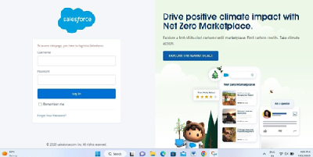

**Object**

Salesforce objects are database tables that permit you to store data that is specific to an organization. Salesforce objects are of two types: Standard Objects: Standard objects are the kind of objects that are provided by salesforce.com such as users, contracts, reports, dashboards, etc.

Salesforce objects are of two types:

Standard Objects: Standard objects are the kind of objects that are provided by salesforce.com such as users, contracts, reports, dashboards, etc.

Custom Objects: Custom objects are those objects that are created by users. They supply information that is unique and essential to their organization. They are the heart of any application and provide a structure for sharing data.

* Creation Of School Object Creation Of Objects For School Management

For this school management we need to create 3 objects School, Parents and Student. The below steps will assist you in creating those objects.

* Click on the gear icon and then select Setup.
* Click on the object manager tab just beside the home tab.

After the above steps, have a look on the extreme right you will find a Create Dropdown click on that and select Custom Object.

On the Custom Object Definition page, create the object as follows:

1. Label: School
2. Plural Label: Schools
3. Record Name: School Name
4. Check the Allow Reports checkbox
5. Check the Allow Search checkbox
6. Click Save

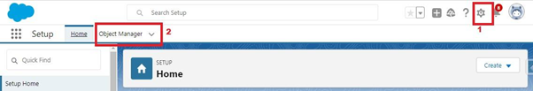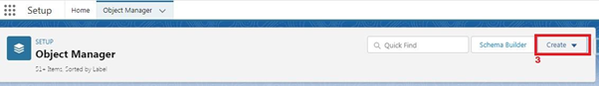

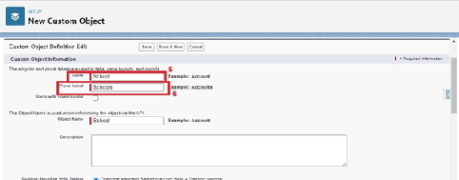

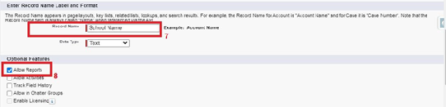

Now create a custom tab. Click the Home tab.

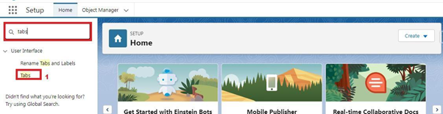

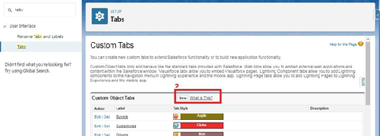

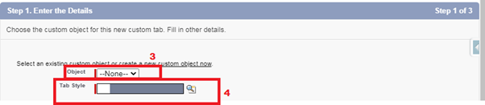

* Create student object
* Click on the gear icon and then select Setup.
* Click on the object manager tab just beside the home tab

After the above steps, have a look on the extreme right you will find a Create Dropdown click on that and select Custom Object.

On the Custom Object Definition page, create the object as follows:

1. Label: Student
2. Plural Label: Students
3. Record Name: Student Name
4. Check the Allow Reports checkbox
5. Check the Allow Search checkbox
6. Click Save.

Now create a custom tab. Click the Home tab, enter Tabs in Quick Find and select Tabs. Under Custom Object Tabs, click New.

For Object, select Students.

For Tab Style, select any icon.

Leave all defaults as is. Click Next, Next, and Save.

* Create Parent Object
* Click on the gear icon and then select Setup.
* Click on the object manager tab just beside the home tab.

After the above steps, have a look on the extreme right you will find a Create Dropdown click on that and select Custom Object.

On the Custom Object Definition page, create the object as follows:

1. Label: Parent
2. Plural Label: Parents
3. Record Name: Parent Name
4. Check the Allow Reports checkbox
5. Check the Allow Search checkbox
6. Click Save.

Now create a custom tab. Click the Home tab, enter Tabs in Quick Find and select Tabs. Under Custom Object Tabs, click New.

* For Object, select Parents.
* For Tab Style, select any icon.

Leave all defaults as is. Click Next, Next, and Save.

**Lightning App**

Apps in Salesforce are a group of tabs that help the application function by working together as a unit. It has a name, a logo, and a particular set of tabs. The simplest app usually has just two tabs.

There are two types of app -

Standard App: Standard apps come with every occurrence of Salesforce as default. Many features like Sales, Marketing, Community, call center, content, Salesforce Chatter, App Launcher, etc are present in it.

Note: The description, Logo, and Label of standard app cannot be altered.

Custom Apps: Custom apps are created according to need of user. Custom Apps are made by using standard and custom tabs together.

Note: Logos for Custom Apps can be changed.

Create The School Management App

1. From Setup, enter App Manager in the Quick Find and select App Manager.

2. Click New Lightning App.

3. Enter School Management as the App Name, then click Next

4. Under App Options, leave the default selections and click Next.

5. Under Utility Items, leave as is and click Next.

6. From Available Items, select Schools, Students, Parents, Reports, and Dashboards and move them to Selected Items. Click Next.

7. From Available Profiles, select System Administrator and move it to Selected Profiles.Click Save & Finish.

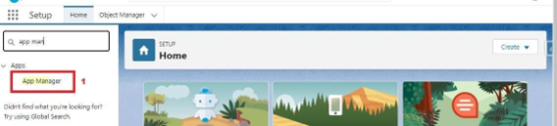

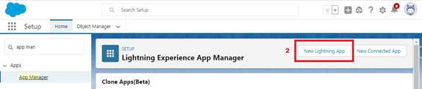

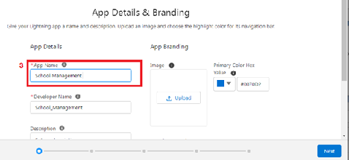

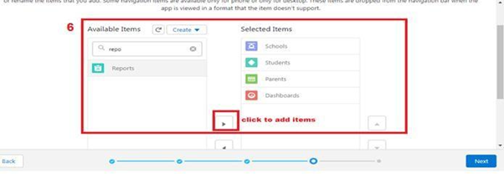

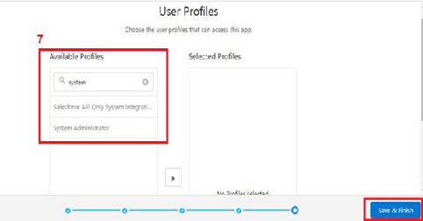

To verify your changes, click the App Launcher, type School Management and select the School Management app.

Note:

* App Launcher-Displays available apps.
* App Name-Displays the current selected app.

Navigation menu -Displays the tabs available inside the app.

**Fields And Relationship**

An object relationship in Salesforce is a two-way association between two objects. Relationships are created by creating custom relationship fields on an object. This is done so that when users view records, they can also see and access related data.

* Creation Of Fields For The School Objects

1. Click the gear icon and select Setup. This launches Setup in a new tab.

2. Click the Object Manager tab next to Home.

3. Select School.

4. Select Fields & Relationships from the left navigation

5. Click New

6. Select the Text Area as the Data Type, click Next.

7. For Field Label, enter Address.

8. Click Next, Next, then Save & New.

9. Follow steps 1 to 3 and create two more Text type field - District & State.

10. Create URL type field & give School website as the field label.

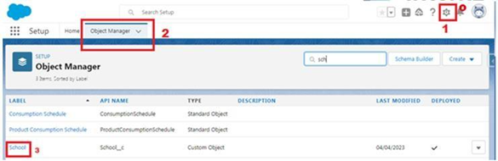

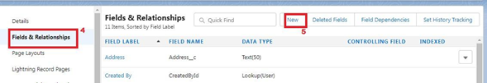

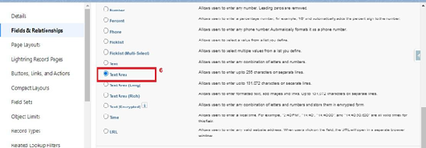

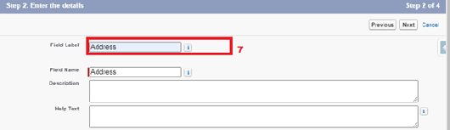

Now let's create the other fields and we must choose the data types of the fields carefully. Let's have a look at it.

For example, a phone number is a number field. For that we need to select the phone as data type.

Let’s see this

Note- Follow above steps 1 to 5 to create field and then follow below step 1. Select the Phone as the Data Type, then click Next.

2. For Field Label, enter Phone Number.

3. Click Next, Next, then Save & New.

* Creation Of Fields For The Student Objects

Note- Follow above steps 1 to 5 to create field and then follow below steps

1. Select the Phone as the Data Type, then click Next.
2. For Field Label, enter Phone Number.
3. Click Next, Next, then Save & New

Let's create a master-detail relationship with School object

Note- Follow above steps 1 to 5 to create field and then follow below steps

1. Select Master-Detail Relationship as the Data Type and click Next.
2. For Related to, enter School.
3. Click Next.
4. For Field Label, enter School.
5. Click Next, Next, Next and Save.

Let’s create a Pick-List field:

Note- Follow above steps 1 to 5 to create field and then follow below steps

1. From Setup, click Object Manager and select Student.
2. Click Fields & Relationships, then New.
3. Select Picklist as the Data Type and click Next.
4. For Field Label enter Results.
5. Select Enter values, with each value separated by a new line and enter these values:
6. Pass
7. Fail
8. Click Next, Next, then Save & New

Let’s create a Number field:

Note- Follow above steps 1 to 5 to create field and then follow below steps

1. Select the Number as the Data Type, then click Next.
2. For Field Label, enter Class.
3. Click Next, Next, then Save & New

Follow steps 1 through 3 and create one more number field with Marks as the field labels.

Let’s create Roll-up summary fields on School Object to calculate the number of students

1. Click gear icon Select Setup, This launches Setup in a new tab.
2. click Object Manager
3. Select School.
4. Click Fields & Relationships
5. Click New.

Select the Roll-up summary field as data type

Enter the field label as Number of students

Click Next

Then select the master object summarized as students

Select count as roll-up andthen click Next, Next and save.

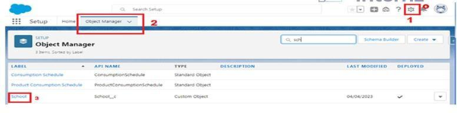

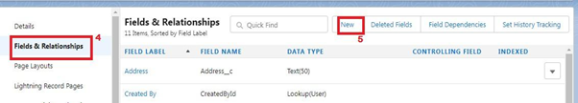

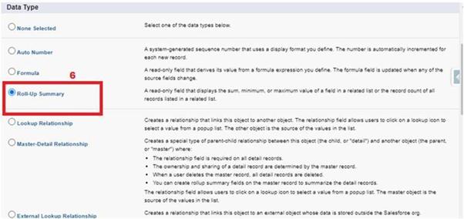

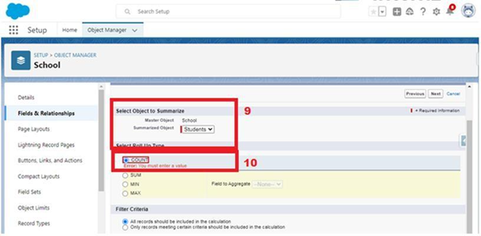

create one more rollup summary field-

* + From Setup, click Object Manager and select School.
  + Click Fields & Relationships, then New.
  + Select the Roll-up summary field as data type
  + Enter the field label as Highest Marks
  + Click Next
  + Then select the master object summarized as students and then select Max as roll-up and then select Marks as field to aggregate.
  + click Next, Next and save.
* Creation Of Fields For The Parent Objects

Select the Text Area as the Data Type, then click Next.

For Field Label, enter Parent Address.

Click Next, Next, then Save & New.

Select the Phone as the Data Type, then click Next.

For Field Label, enter Parent Number.

Click Next, Next, then Save & New